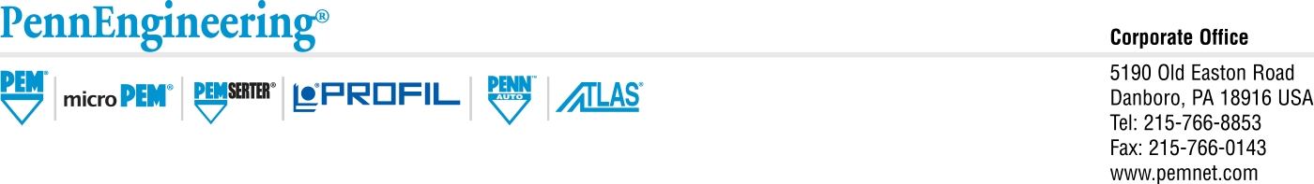

1/2024

**RE:** Country of Origin and Russian Raw Material Inquiries

Customers of PennEngineering,

As part of PennEngineering’s catalog offering for PEM products we manufacture parts in various regions globally, these include APAC, EU and North America. To this end when purchasing from the catalog PennEngineering cannot guarantee a specific COO for continuous supply. NOTE: This may be available for a specific lot or work order upon request.

In addition to COO applicability PennEngineering is diligent in our review of where our raw material is provided and with whom we partner. We use Assent LLC as part of our diligence in the capture and review of data in this area.

To date we are certain that we do not purchase raw material from the Russian Federation or any countries of concern in the African continent.

Any questions regarding PennEngineering’s ability to deliver our products in any region should be directed to your local sales team or through the compliance portal.

|  |
| --- |
|  |
| Rocky,  Rocky Pinheiro, Ph.D.  Global Vice President of Quality, PennEngineering  [rpinheiro@pemnet.com](mailto:rpinheiro@pemnet.com)  586-610-3500 |
|  |
|  |
|  |
|  |
|  |
|  |
|  |
|  |
|  |
|  |
|  |
|  |
|  |
|  |
|  |
|  |
|  |
|  |
|  |
|  |
|  |
|  |
|  |
|  |
|  |
|  |
|  |